Group 4 - Homework #1
BUAD 689, Predictive Analytics
Kevin Carbrey, Clay Coleman, Charlie Ellis, Karen Fireman, Benny Horowitz, E. Lee Rainwater
Mays Business School, Texas A&M University, College Station, Texas, USA, lee.rainwater@tamu.edu

Univariate Analysis
Histograms and Summary Statistics of Sales_Price, Lot_Area, Second_Flr_SF

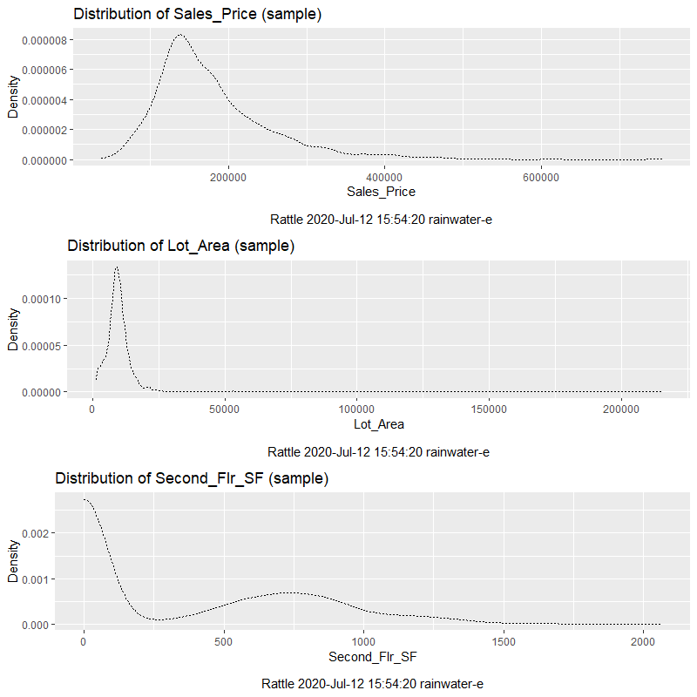
Histogram Distributions, grouped by Zoning
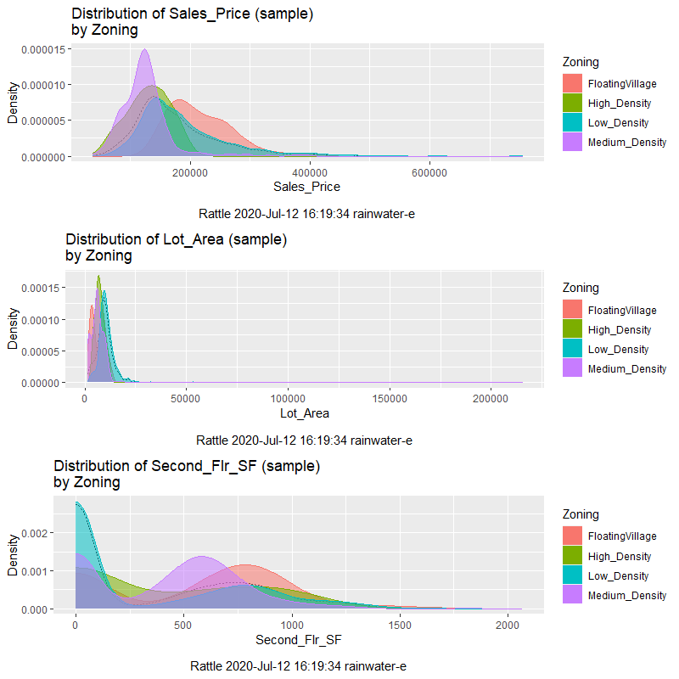
Observations:
Sales_Price – FloatingVillage and Low_Density have the highest means. While all zones are somewhat right-skewed, these two zoning categories have the largest volumetric tails, meaning that substantial quantities of these housing units are skewed toward the higher-priced end of the market. The FloatingVillage category appears “double-humped”, indicating that there are possibly two sub-populations.
Lot_Area – Low_Density units have the highest mean Lot_Area, as would be expected. Although it appears from the plot that Medium_Density has the highest maximum lot area, a cross-tab shows otherwise:
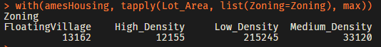
Second_Flr_SF – For each of the four zoning categories, Second_Flr_SF exhibits a “double-humped” distribution with significant right-skewness. In each case, one hump is centered at zero. This indicates that there are a large number of houses in each zoning category which have no second floor, and that any further analysis of this variable needs to be segregated into units with and without second floors. In particular, any statistics based upon Second_Flr_SF are useless unless units without second floors are segregated. It is also not clear whether square footage for floors above the second floor are lumped into Second_Flr_SF or ignored.

Further Exploration

Scatterplot Matrix
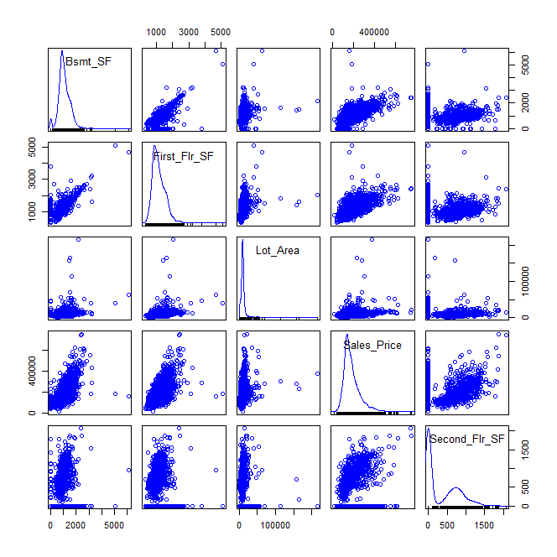
Observations:
            - There appears to be little correlation between Lot_Area and Second_Flr_SF.
            - There is a strong correlation between Sales_Price and most interval variables.
            - The relationship between First_Flr_SF and Lot_Area displays an interesting split in outliers…exceptionally large houses on modest lots, and modest houses on exceptionally large lots.

Distribution Pairs + Histograms
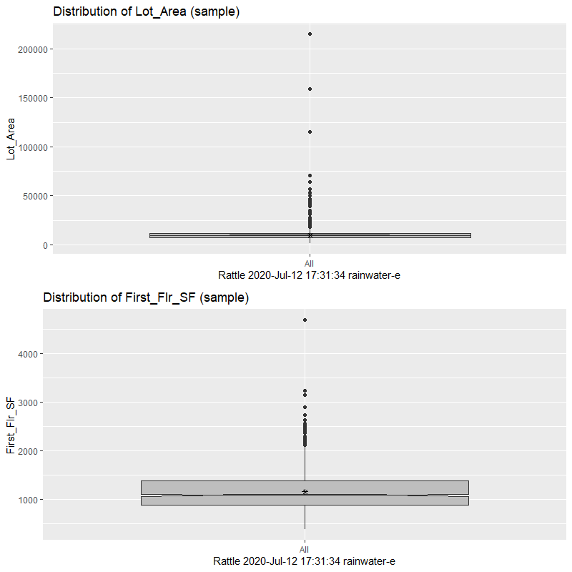
Observations:
Rattle will not generate distribution pair plots unless a grouping category is selected.

Regression Model
NOTE: Clay shared that we should convert our characters to factors:
DataSet <- mutate_if(DataSet, is.character, as.factor)
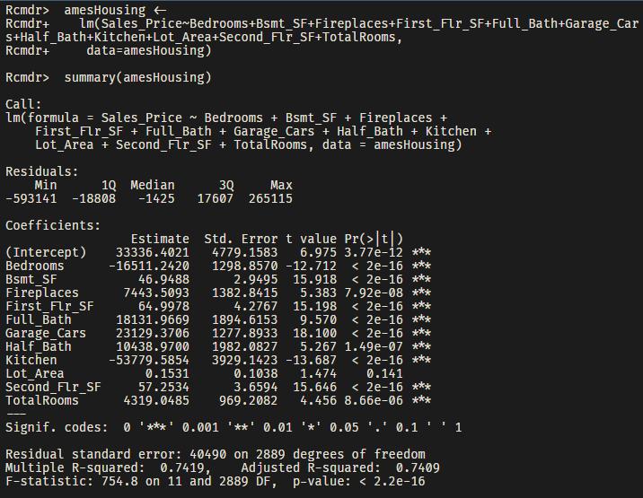
All variables except Lot_Area are considered significant predictors upon the basis of their p-values ≤ 0.05. However, the model is of questionable value as a result of the assumptions of normal distribution (a basic assumption for linear regression) being violated for most variables.
One suggestion for improvement would be to combine First_Flr_SF and Second_Flr_SF into a variable representing total square footage. This will likely present a better correlation of price and square footage by addressing the heavy concentration of units with zero second floor square footage. Additionally, the presence of a second floor could be coded as a binary variable.

Log Transformation
Based upon the shape of the scatterplots, Sales_Price and First_Flr_SF appear to be candidates for logarithmic transformation. Specifically, the manner in which the variance for both variables increases with increasing x indicates that heteroscedasticity could be improved via transformation. A scatterplot matrix of these variables indicates that the proposed transformation indeed improves heteroscedasticity as shown in the figure below.
Figure 1—Scatterplot matrix of first floor square footage and sales price, both untransformed and transformed

Linear Regression of Transformed Data
A linear regression containing the previous variables, but with both Sales_Price and First_Flr_SF having been logarithmically transformed is shown below:
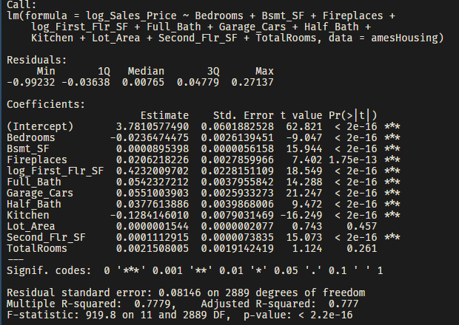
The R² value for this model is improved slightly over the previous (0.777 vs. 0.749). It is expected that outliers may preclude higher values of R² than this.

Model Prediction

